

**MDWDemo Cookbook – Table of Contents****Prerequisites:**

**Eclipse with the MDW Plug-In**

Get Started with BPM Cloud Development.

**Java Container (Apache Tomcat 7.x)**

Run Locally for Advanced Capabilities.

**Get the mdwdemo Project:**

**1: Add the Git Repository**

Add the Centurylink Labs MDW repository in Eclipse.

**Build a Workflow:**

**1: Build a Workflow Process**

Create a basic process definition with Dynamic Java Code.

**2: Tomcat Setup & Running Your Process**

Execute your process and debug your custom code.

**Eclipse with the MDW Plug-In**

Contents Next

**Set Up Eclipse on Your PC:**

* Make sure you have Java Runtime 7 or 8 installed on your computer:
  + [**http://www.oracle.com/technetwork/java/javase/downloads**](http://www.oracle.com/technetwork/java/javase/downloads)
* Install Eclipse Mars (4.5.x) for JavaEE Developers:
  + [**https://www.eclipse.org/downloads**](https://www.eclipse.org/downloads)
* Launch Eclipse. Here’s an example command line that includes appropriate JVM memory settings for running and debugging:

**C:\eclipse_4.5.2\eclipse.exe -vm C:\jdk1.7.0_45\bin\javaw.exe -vmargs -Xms512m -Xmx1024m**

* Install the latest version of the MDW Plug-In via Eclipse Software Updates (Help > Install New Software > Add > **http://lxdenvmtc143.dev.qintra.com:6101/MdwPlugin** > Install).
* Make sure Eclipse has a Java 7 or Java 8 Installed JRE available in your workspace (Window > Preferences > Java > Installed JREs). ***For deploying on Tomcat you will need to install JDK 7 or 8.***

**Optional Plug-Ins:**

* Groovy Eclipse Plug-In (Groovy script syntax highlighting, auto-complete, etc.)

**http://dist.springsource.org/release/GRECLIPSE/e4.5**

* Quantum DB Plug-In (Database querying)

**http://quantum.sourceforge.net/update-site**

**Java Container (Apache Tomcat 7.x)**

Previous Contents Next

You can perform many cloud development activities using a remote workflow project. However, there are certain advantages to being able to deploy locally. The differences between local and remote development are described in later sections of this tutorial. To be able to develop locally you need one of the following containers installed. *Chances are if you're deploying in Cloud Mode you'll choose Apache Tomcat.*

**Supported Java Containers:**

* Apache Tomcat:
  + [**http://tomcat.apache.org/download-70.cgi**](http://tomcat.apache.org/download-70.cgi)
* Apache ServiceMix:
  + [**http://servicemix.apache.org/downloads.html**](http://servicemix.apache.org/downloads.html)
* JBoss Fuse 6.1.0:
  + [**http://www.jboss.org/products/fuse/download**](http://www.jboss.org/products/fuse/download)

**MDW Database:**

* Starting with version 5.5, MDW saves the workflow assets you create on your local file system until you commit them to a version control repository such as Git. Runtime data is stored in a MySQL or Oracle database. Supported versions are listed in the MDW [Compatibility Matrix](http://cshare.ad.qintra.com/sites/MDW/Releases/Compatibility). Generally for cloud development you'll point to a pre-existing central database. If you want to host your own database, you'll need to configure an instance of MySQL with the MDW db schema. The SQL scripts for installing the MDW schema are available here:
  + [**http://cshare.ad.qintra.com/sites/MDW/Developer%20Resources/MDW%20Database**](http://cshare.ad.qintra.com/sites/MDW/Developer%20Resources/MDW%20Database)

**Get the mdwdemo Project**

Previous Contents Next

**1. Add the Git Repository**

The mdwdemo workflow project is hosted in the [CenturyLink Labs](https://labs.ctl.io/) MDW Git Repository. If you prefer to use command line Git, clone the repository from **https://8.22.8.164/mdw/mdwdemo.git** using credentials **mdw/ldap_0123**.

**Disable Git SSL Verification in Eclipse:**

* Our SSL certificate is self-signed and is not trusted by Git. Therefore, the first step is to disable (at least temporarily) SSL verification. From the Eclipse menu, select Window > Preferences > Team > Git > Configuration > Add Entry…
* Create an entry like this:

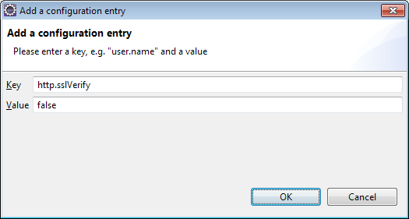

**Clone the mdwdemo Project into Your Workspace:**

* Access the Git Repositories view by selecting Window > Show View > Other > Git > Git Repositories:
* Copy the repository URL into your clipboard: https://8.22.8.164/mdw/mdwdemo.git.
* Right-click in Git Repositories view and select Paste Repository Path or URI.
* Enter **mdw** for the User and **ldap_0123** for the Password:

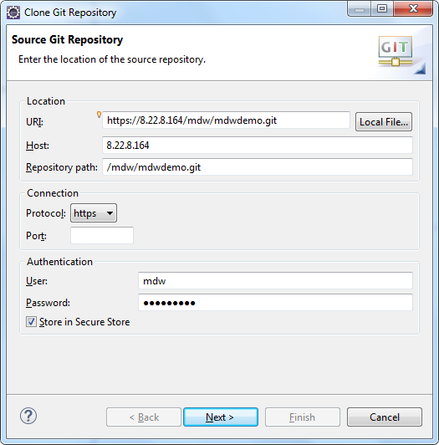

* Click Next and make sure the **master** branch is selected:

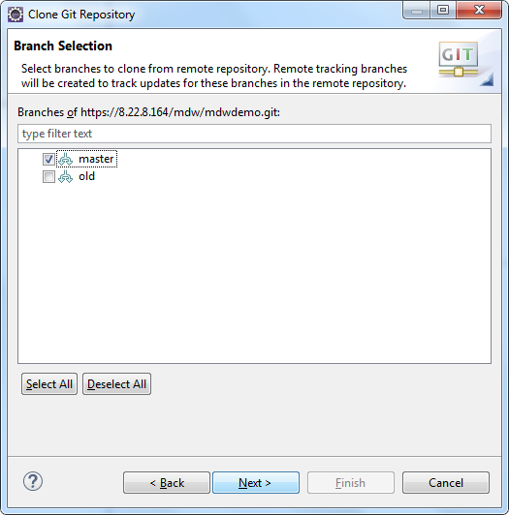

* Click Next again. Point to your workspace/mdwdemo for the Destination Directory. Check "Import all existing Eclipse projects after clone finishes". Then click Finish.

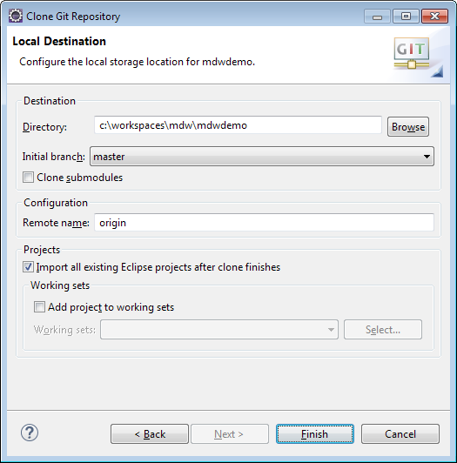

**MDW Designer Perspective:**

* To best view the workflow assets, switch to Designer Perspective (Window > Perspective > Open Perspective > Other > MDW Designer).
* In Process Explorer view expand the mdwdemo project to see the included workflow packages.
* It will make more sense after you have gone through creating your first workflow process. But for now, you can take a look at the demo intro process to get a feel for it by opening the com.centurylink.mdw.demo.intro package and double click the HandleOrder process in the mdwdemo project and you will be able to view the demo Process design model.

**Build a Workflow**

Previous Contents Next

**1. Build a Workflow Process**

**Create a Workflow Package:**

* The top-level branches in the project tree represent workflow packages. Your work should be incorporated in a dedicated package, which will be used for managing resources and for insulating your work from that of other users. For further details refer to the Eclipse Cheat Sheet (Help > Cheat Sheets > MDW Workflow > Importing, Exporting and Versioning).
* Create your workflow package by right-clicking on your project (i.e., mdwdemo) and selecting New > MDW Package. Note: make sure your package name complies with Java package naming requirements (eg: no spaces) since it will contain dynamic Java resources. Leave the Workgroup dropdown blank.

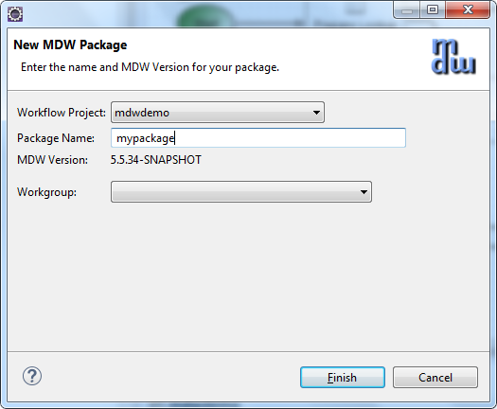

**Create the Process:**

* Right-click on your new package in Process Explorer and select New > MDW Process. Enter the process name and description (no workgroup), and click Finish.

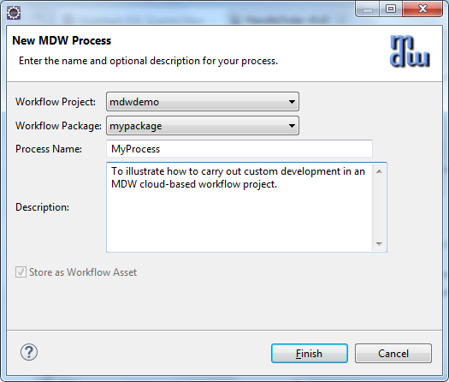

**Add some Process Variables:**

* Double-click on the process title or on a blank area somewhere in the canvas to display the Properties View. Select the Variables property tab and add an input variable (request) and two local variables (orderId and validationResult) with types as depicted below.

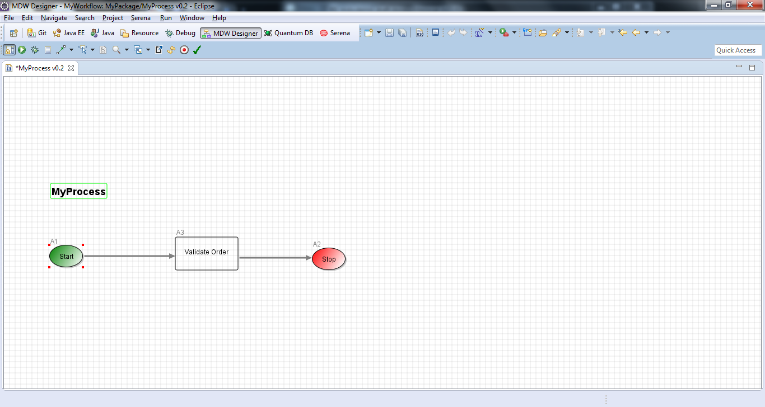

* Save your process design by selecting File > Save from the menu (or by clicking the disk icon in the Eclipse toolbar, or by typing ctrl-s). Elect to overwrite the current version and to remember this selection for future saves. During iterative development for convenience you'll sometimes overwrite the existing version of a process definition. However once you've exported to another environment you'll want to increment the version since you cannot re-import a changed process with the same version number. Details are covered under Help > Cheat Sheets > MDW Workflow > Importing, Exporting and Versioning.

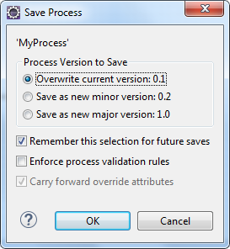

**Create a Dynamic Java Custom Activity:**

* Right-click on your package in Process Explorer and select New > Activity > General Activity. On the first page of the wizard, enter a label to identify your activity in the Toolbox view.

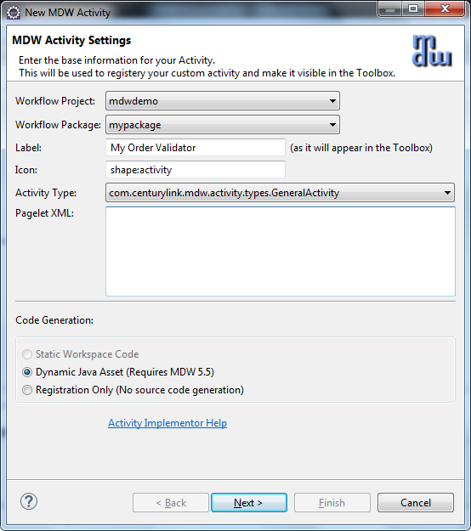

* Click Next and enter a class name for your activity implementor. The Java package name is the same as your workflow package name.

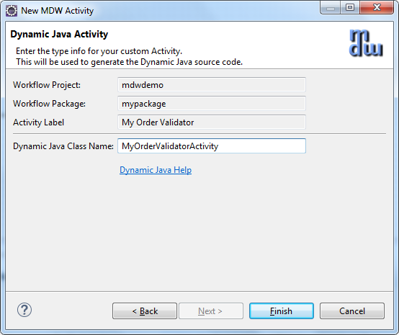

* When you click Finish the Java code for a skeleton implementation is generated. You'll also see the Java class under your package in Process Explorer. This source code resides under src/main/workflow and is known as a Dynamic Java workflow asset. It's dynamic because it can be changed without needing any kind of application deployment. Naturally there are rigorous controls in place to prevent unauthorized modifications. You should have been granted permissions in the MDW Demo environment to create and modify workflow assets. With Dynamic Java, as with all types of workflow assets, MDW provides facilities for versioning, rollback and import/export for migrating between environments.
* Update the generated Java source code to resemble the following:

**package** mypackage;

**import** com.centurylink.mdw.common.utilities.logger.StandardLogger.LogLevel;

**import** com.centurylink.mdw.common.utilities.timer.Tracked;

**import** org.w3c.dom.Document;

**import** org.w3c.dom.Node;

**import** com.centurylink.mdw.activity.ActivityException;

**import** com.centurylink.mdw.model.value.activity.ActivityRuntimeContext;

**import** com.centurylink.mdw.workflow.activity.DefaultActivityImpl;

/**

* MDW general activity.

*/

@Tracked(LogLevel.***TRACE***)

**public** **class** MyOrderValidatorActivity **extends** DefaultActivityImpl {

/**

* Here's where the main processing for the activity is performed.

*

* **@return** the activity result (aka completion code)

*/

@Override

**public** Object execute(ActivityRuntimeContext runtimeContext) **throws** ActivityException {

loginfo("Validating order...");

Document request = (Document) getVariableValue("request");

Node orderIdNode = request.getFirstChild().getFirstChild().getNextSibling();

String orderId = orderIdNode.getFirstChild().getNodeValue();

setVariableValue("orderId", orderId);

**boolean** valid = **true**;

String msg = "Success";

**if** (!orderIdNode.getLocalName().equals("orderId"))

msg = "Missing order ID.";

valid = msg.equals("Success");

setVariableValue("validationResult", msg);

**return** valid;

}

}

* Now if you switch back to your process the new activity should appear in the Toolbox View. From the toolbox, drag your activity onto the canvas and insert it into your process flow between the Start and Stop activities.

Tip: To draw a link (or *transition* in MDW terminology) between activities on the designer canvas, hold down the Shift key on your keyboard, Click on the upstream activity, and continue holding down the mouse left click button while dragging the cursor to the downstream activity ("*shift-click-drag*")*.*

* Your activity can be dragged like this and used in other processes designed by other users. Actually the proper term in MDW for this reusable element in the Toolbox is *activity implementor*. This conveys the idea that it's actually a template to be dragged and configured as an *activity* in the canvas, and it also conveys the fact that it always corresponds to a Java class. To take this reuse concept a step further, your activity implementor can be made discoverable so that it can easily be imported into other environments and reused across domains. If you click on the light bulb icon at the top of the Toolbox you'll get an idea how items in the palette can be imported from a file or discovered in the corporate repository.
* Double click the activity in the canvas, and in its Definition property tab change the label to something like "Validate Order". When you click back on the canvas the activity reflects its new label.



* Note: If you select the Design property tab for your activity you'll see that it's blank. A non-trivial activity would allow certain aspects (such as endpoint URLs) to be configurable, so that it could readily be reused. For example, take a look at the Design tab for the Start activity. You control what appears on the Design tab through the pagelet XML for the activity implementor. In the creation wizard we left the pagelet XML blank, so the Design tab for our activity is empty. But to continue with the example of the start activity, find the Process Start icon in the Toolbox and view its Design tab (for the implementor, not the activity on the canvas). This gives you an idea of how the pagelet XML relates to the fields on the Design tab for the activity user. Since we're on the subject you may be interested to know how you can customize the icon for your activity implementor. On the Definition tab you can choose one of the built-in shapes, or more flexibly choose any GIF, JPG or PNG asset that you can easily add to your workflow package.

**Add Multiple Activity Outcomes:**

* Drag a Process Finish activity from the Toolbox, and add another outbound transition from "Validate Order". Assign Result Code values of "true" and "false" to the respective transitions as illustrated below. Save your process definition. The value passed in setReturnCode() in your activity's execute() method dictates which of these two paths will be traversed at runtime.

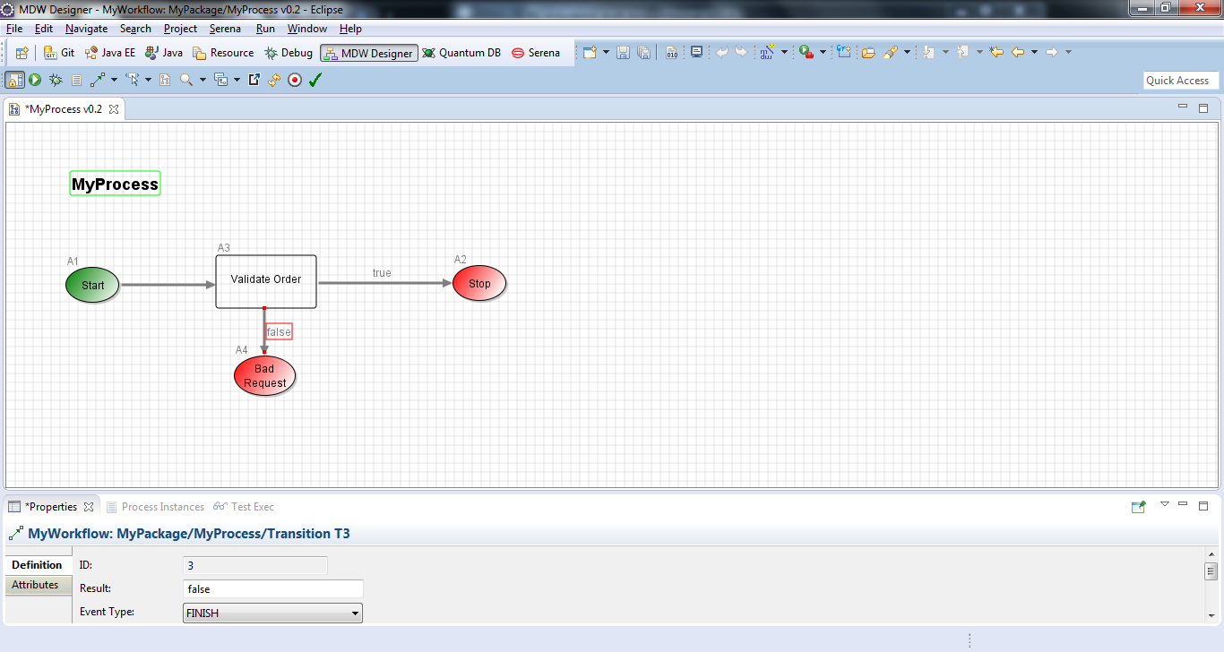

**Build and Update mdwdemo project:**

Before you can deploy your demo project to your server, you will need to do a maven build. You only need to do this once to generate the required dependent jar files.

* On your eclipse, switch to Java perspective.
* Right click on the pom.xml file in your mdwdemo project, choose ***Run As*** and ***2. Maven build****.*
* Now, you will need to update your mdwdemo project from Java perspective.   
  Right click the mdwdemo project, select ***MDW Update*** then ***Update Framework Libraries*** to download the latest war file.
* Now, you will need to update the Admin UI. Right click your mdwdemo project from Java perspective again and select ***Properties***, ***MDW*** ***Workflow*** then ***Extension***. Put a check mark on Admin UI and click Ok.

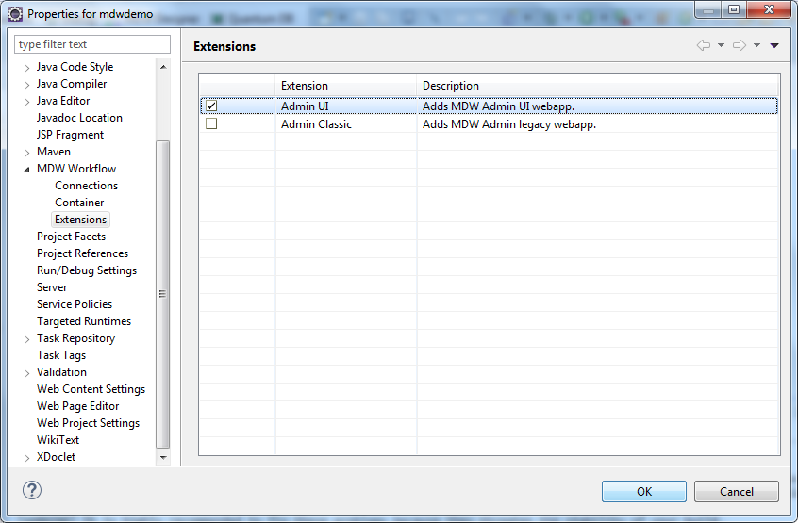

* On the Admin UI Extension pop-up window, select the latest version and click Ok.  
  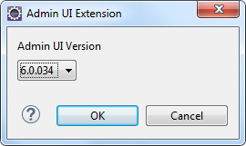

**2. Tomcat Setup & Running Your Process**

Previous Contents

**Ensure Permissions:**

* To follow the remaining steps in this tutorial you need to be granted the appropriate roles in the MDW demo database (unless you've installed a database locally). An administrator can grant you appropriate access using the MDWHub webapp. For a detailed discussion of this topic, refer to the "Roles and Permissions" section of the [MDW Designer User Guide](http://qshare.ad.qintra.com/sites/MDW/User%20Documentation/MDW%20Designer%20User%20Guide.doc).

**Create a Tomcat Server:**

* To execute a workflow process you need a server running with MDW deployed. For debugging in Eclipse the easiest way to set this up is through a Web Tools Platform server instance. From the menu select File > New > Other > Server > Server. Click Next and select Apache > Tomcat 7.0 (MDW) from the options. To be able to debug your Dynamic Java it's important that you select ***Tomcat 7.0 (MDW)*** instead of the standard ***Tomcat 7.0 Server***. The server name is arbitrary, so you can make is something friendlier than the default.

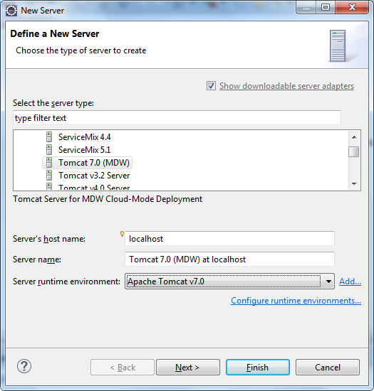

* If you've not previously used a Tomcat 7 runtime in Eclipse, clicking Add takes you to a page where you specify your Tomcat location. Make sure to select a JDK to compile the code and that the selected JDK is Java 1.7.x

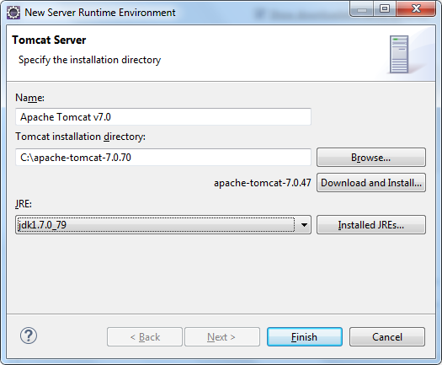

* The final page of the New Server wizard is where you designate your workflow project to be deployed on the server. After that, click Finish to create the server instance.
* If the Servers view is not visible in your current perspective, from the menu select Window > Show View > Other > Server > Servers. You should see your Tomcat 7 server in this view. You can double-click the server to edit its configuration. Expand the Timeouts section, change the start timeout value to 300 seconds, and hit Ctrl-S to save your changes. Then close the editor.

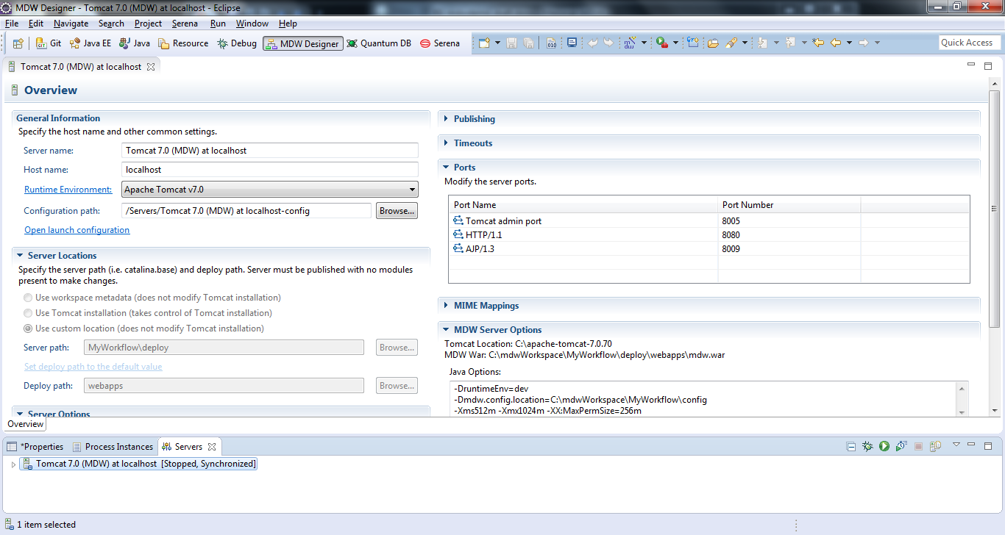

* Before you start the server, you will need to add your mdwdemo project to your server instance. Right click the server instance, select Add and Remove… and select the mdwdemo from the left pane and click the Add to move it to the right pane.

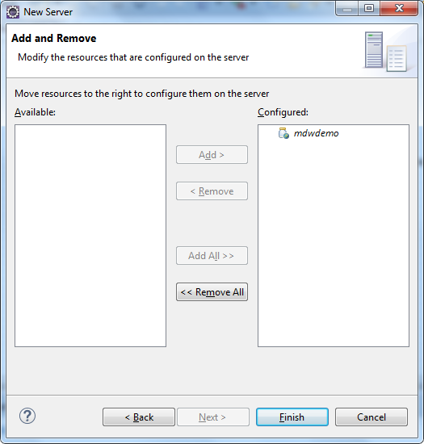

**Run Tomcat:**

* Now that you've created the WTP server instance, the Servers view gives you a handy way to start and stop Tomcat. And output is directed to the Eclipse Console view, where you can click on stack traces to open associated source code (including MDW Framework code and Dynamic Java). Start your server in debug mode by right-clicking on it and selecting Debug (or use the icon in the Servers view toolbar).
* The first time you start your server Tomcat explodes the mdw.war file in your deploy/webapps directory and caches the deployable content. This can sometimes take a minute. With the server running you should see MDW output in the Eclipse Console view. You can safely ignore any Dynamic Java compilation errors unless they pertain to the custom activity you created in   
  **1. Build a Workflow Process** step.

Tip: When you upgrade to a new MDW build version in Eclipse, Designer automatically downloads the corresponding mdw.war file into your deploy/webapps directory. If at any time you want to clean out the MDW deployment and start fresh, you can delete mdw.war and the exploded mdw directory (and for a very thorough cleansing you can even delete the Tomcat cache under deploy/work/Catalina/localhost/mdw). Then you can deploy from scratch from Package Explorer view by right-clicking on your workflow project and selecting MDW Update > Update Framework Libraries.

* Make sure your project is added to your Java Build Path/Source. You will need to do this from a Java or Resource perspective.
* You can confirm that MDW was successfully deployed by accessing MDWHub in your browser:

<http://localhost:8080/mdw>

**Open the Process Launch Dialog:**

* Right-click on your process that is under your workflow package in Process Explorer view and Select Run. You can also right-click on your Designer and Select Run. Designer will present the launch dialog and open a connection to the server to confirm that it's running (required for launching a process).
* On the Process tab in the launch dialog, select "Monitor Runtime Log" and "Process Instance Live View" to get a feel for how you can watch your process flow in real time.

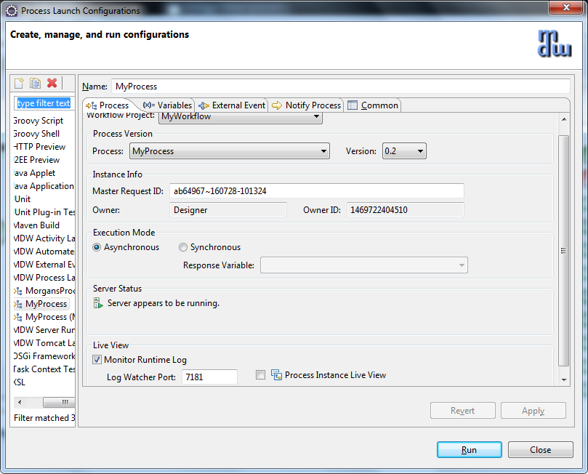

**Populate the Input Variable:**

* Select the Variables tab in the launch dialog, and populate the request variable with the following content.

<order>

<orderId>N12345678</orderId>

</order>

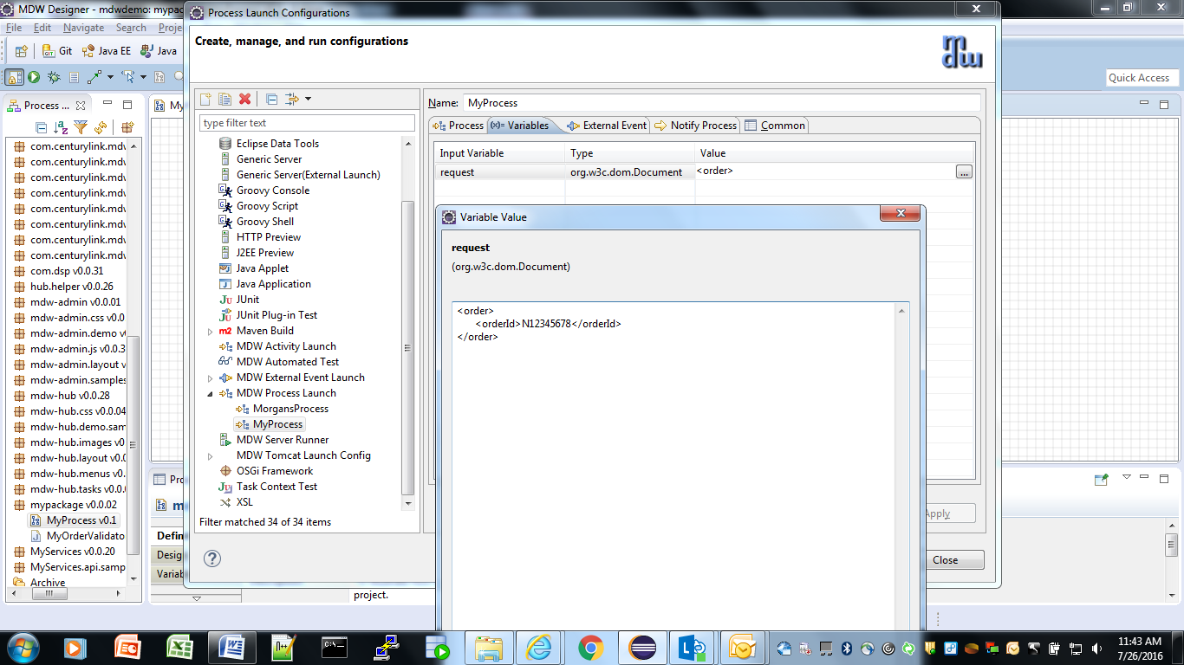

**Launch and View an Instance:**

* Click Run on the launch dialog to run an instance of your process. In the Live View you should see the new instance progress down the happy path with the Validate Order outcome equal to 'true'. For processes not displayed in Live View, you can open an instance manually by right-clicking on your process in Process Explorer view and selecting View Instances. The latest instance will appear at the top of the Process Instances list, and you can double-click to open its runtime view.
* In Designer Perspective when a process instance is visible, a legend appears showing what the borders surrounding the activities mean. To inspect the runtime variable values for the instance, click the Values property tab.

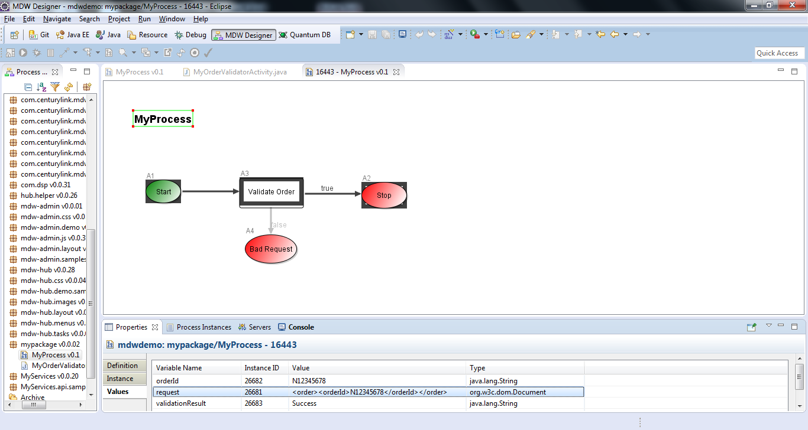

**Change Java Code and Rerun with a Breakpoint:**

**if** (!orderIdNode.getLocalName().equals("orderId"))

msg = "Missing order ID.";

**else** **if** (!Character.*isDigit*(orderId.charAt(0)))

msg = "Order ID must begin with a digit.";

* Change the Java source so that validation expects an order number that begins with a digit:
* Save your changes and run your process again to confirm that this time it fails validation with the appropriate validationResult message. Note: In the real world Order IDs would likely be unique for each request, so you may want to change the XML input on the process launch Variables tab to something other than the value remembered from the last launch.
* Let's pretend like we don't know why validation is failing, so we'd like to debug our Dynamic Java source code. Set a breakpoint on the line with the *if* condition by double-clicking on the marker bar on the left side of Eclipse's Java editor.
* Run your process again, but this time uncheck "Monitor Runtime Log" on the Process tab in the launch dialog so that Live View doesn't steal focus while you're debugging. After clicking Run, switch to the Debug perspective in Eclipse by selecting Window > Open Perspective > Debug. When process flow reaches your validator activity, you should see the usual green highlighting in the editor. Here you can step through the code and evaluate variables in the usual way as described in [this section](http://help.eclipse.org/luna/topic/org.eclipse.jdt.doc.user/tasks/task-stepping.htm?cp=1_3_6_1_4) of the online Eclipse help docs.
* When you're done debugging, continue execution to let the process complete. You can view the new instance by right-clicking on the process in Process Explorer and selecting View Instances. Double-click on the top instance row to confirm that this second instance took the Bad Request path. Make sure that your tomcat server is up to view the Process Instances.